Monthly Performance Report – March 2026
Kestrel Ridge Wind Farm (75.6 MW)
David Chen · 09 April 2026 · KR-OPS-RPT-2026-03

1. Summary
Kestrel Ridge generated 21.7 GWh in March 2026, 0.0 % above the P50 budget of 21.7 GWh. Time-based availability was strong at 97.7 % (contract target 97.0 %). Mean hub-height wind speed of 9.0 m/s was close to the long-term mean (9.0 m/s). Compared with March 2025 (20.4 GWh), output was up 1.3 GWh.
Endoscope campaign completed: 16 gearboxes without findings, T-12 shows early indications on the ISS bearing. An up-tower bearing replacement for T-12 is planned for May in a low-wind window.

2. Production and key figures
KPI | March 2026 | Budget / target | YTD 2026 | YTD budget
Net generation (GWh) | 21.7 | 21.7 | 66.4 | 68.1
Time-based availability | 97.7 % | 97.0 % | 96.0 % | 97.0 %
Capacity factor | 38.6 % | 38.6 % | 40.7 % | –
Mean wind speed at hub height (m/s) | 9.0 | 9.0 | – | –
Source: Kestrel Ridge SCADA, revenue meter at 132 kV point of connection. Budget = P50 (2024 post-construction yield assessment).
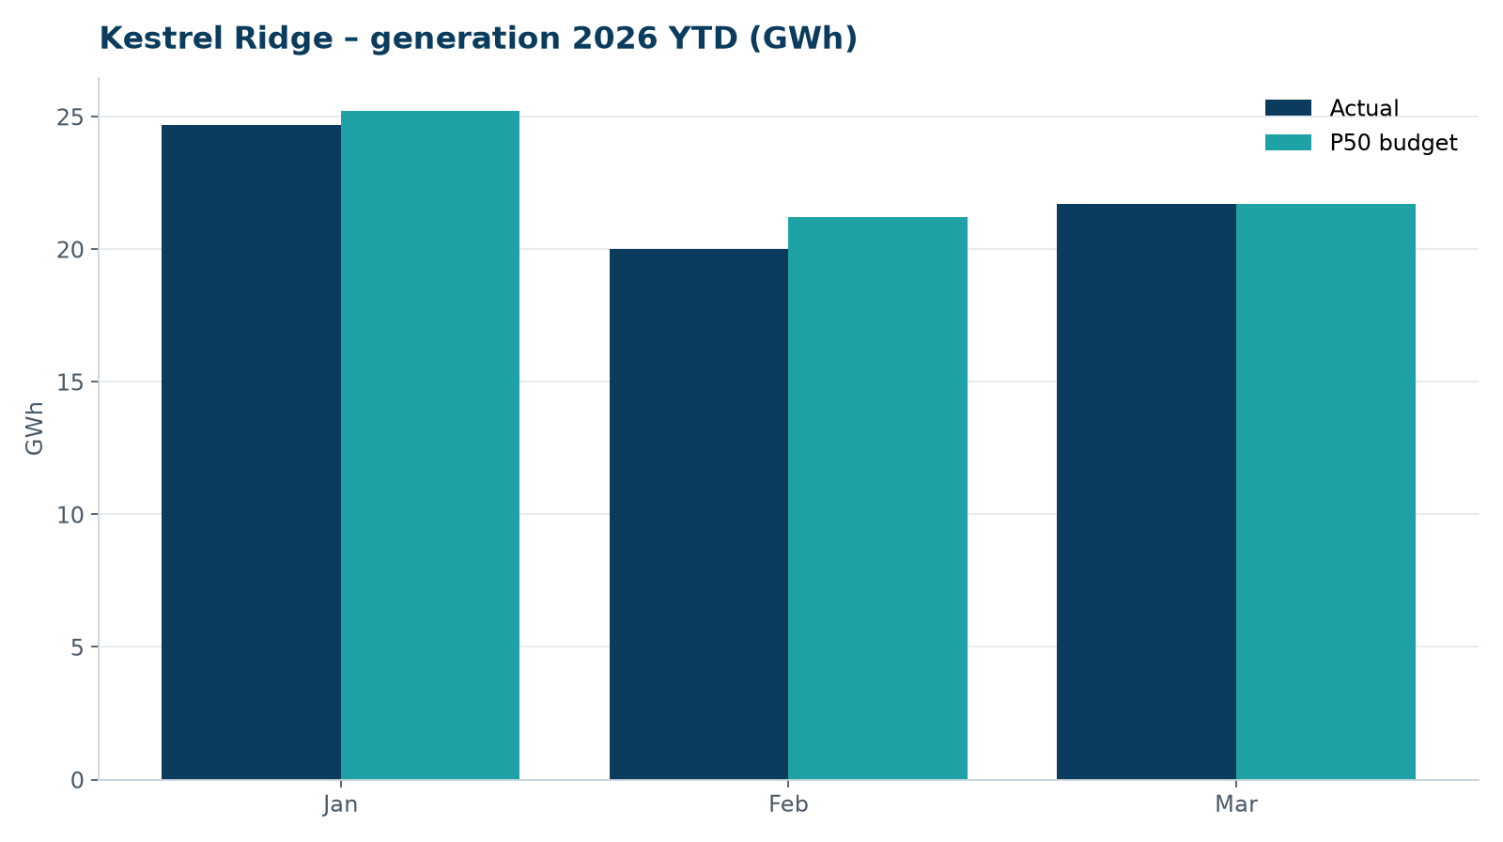
Monthly generation vs. P50 budget, 2026 year to date

3. Availability and downtime
Total turbine downtime attributable to the contractor amounted to 25 turbine-hours for the top events listed below. No grid or force majeure exclusions were claimed this month.
Turbine | Event | Downtime (h)
T-08 | pitch motor encoder fault on blade A | 12
T-01 | nacelle cooling fan motor failure | 9
T-15 | service lift fault – lift locked out, turbine stopped for rescue cover | 4
Top downtime events of the month (SCADA event log, reviewed with Highline Wind Services).

4. Maintenance
- 14 corrective work orders closed, 1 still open at month end.
- Substation monthly inspection completed; no abnormalities on the 33/132 kV transformer.

5. Health, safety and environment
Indicator | Month
Hours worked on site (Highline + Weyland) | 2,446
Lost time injuries | 0
First aid cases | 0
Near misses reported | 0
Safety observations | 4
Environmental incidents | 0

Toolbox talks this month covered rescue from the service lift.

6. Outlook
The P50 budget for next month assumes normal seasonal wind; no planned outages beyond routine maintenance.
Prepared by Sara Lindgren (Performance Analyst); reviewed by Ben Okoye (Site Manager) and David Chen (Asset Operations Manager).

